**Case Study – Windows Server 2019**

**Part 1**

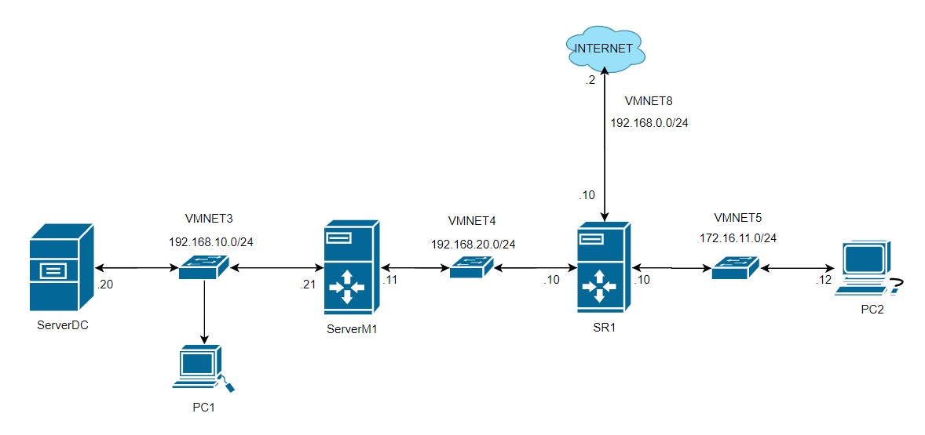

# Step 1. Create Windows Server 2019 and Windows workstation 10 templates

1. Install a new Windows Server 2019 Datacenter server (Desktop experience) with following settings in VMware Workstation.
   1. CPU = 1
   2. Memory = 4 GB
   3. Storage = 80 GB
   4. Network connection = NAT
2. Install the OS and set default password to **Pa$$w0rd**.
3. Disable IE Enhancements in Server Manager.
4. Install Google chrome browser and set it as the default application.
5. Install VMware Tools
6. Sysprep the Server (OOBE+Generalize+Shutdown). Once it is shutdown. **DO NOT POWER IT ON AGAIN.**
7. Install a new Windows 10 VM (Windows 10 Pro) with following settings in VMware Workstation.
   1. CPU = 1
   2. Memory = 4 GB
   3. Storage = 60 GB
   4. Network connection = NAT
8. Install the OS and set username to Admin and password to **Pa$$w0rd**.
9. Install Google chrome browser and set it as the default application.
10. Install VMware Tools.
11. Sysprep the workstation (OOBE+Generalize+Shutdown). Once it is shutdown. **DO NOT POWER IT ON AGAIN.**
12. The Server 2019 and Windows 10 templates that we created in previous steps will be used to create all 5 virtual machines that we need for this project. Clone Windows Server Template and Create 3 VM’s (ServerDC, ServerM1 & SR1 server). Clone Windows 10 template and create 2 new VM’s (PC1 & PC2).

*(Note: Cloning will be done in VMware workstation. We are not using Hyper-V for this project. To clone, right click on Template VM name > Manage > Clone. In clone type, choose to* ***Create a full clone****.)*

# Step 2: Configure ServerDC as follows: (Windows 2019 Data Center)

1. Server name: ServerDC-(your initals) example ServerDC-JS
2. Ethernet 0 - IP Address – 192.168.10.20/24 connected to VMnet3
3. Default Gateway – 192.168.10.21, DNS Address – 8.8.8.8
4. Allow the server to be pinged my allowing icmp-echo request in through the firewall
5. Promote to domain controller with domain name nsa-(your initials).local example nsa-JS.local
6. Take a snapshot while server is powered off and name it ServerDC promoted to DC.

# Step 3. Configure ServerM1 as follows: (Windows 2019 Data Center)

1. Server name: ServerM1-(your initals) example ServerM1-JS
2. Ethernet 0 - IP Address – 192.168.10.21/24 connected to VMnet3
3. Default Gateway – None
4. DNS Address – 192.168.10.20
5. Ethernet 1 – IP Address – 192.168.20.11/24 connected to VMnet4
6. Default Gateway – 192.168.20.10
7. Allow the server to be pinged my allowing icmp-echo request in through the firewall
8. Join ServerM1 to the new domain created in Step 2.
9. Take a snapshot while server is powered off and name it ServerM1 joined to domain

# Step 4: Configure PC1 as follows: (Windows 10)

1. Workstation name: PC1
2. Ethernet 0 – Leave the IP address dynamic and connected to VMnet3
3. Take a snapshot while pc is powered off and name it PC1 - Initial Config

# Step 5. Configure PC2 as follows: (Windows 10)

1. Workstation name: PC2
2. Ethernet 0 – IP address 172.16.11.12/24 and connected to VMnet5, GW – 172.16.11.10 c. DNS Address - 8.8.8.8

d. Take a snapshot while pc is powered off and name it PC2 - Initial Config

# Step 6. Configure SR1 as follows: (Windows 2019 Data Center)

1. Server name: SR1-(your initals) example SR1-JS
2. Ethernet 0 - IP Address – 192.168.20.10/24 connected to VMnet4, DG - None
3. Ethernet 1 - IP Address – 172.16.11.10/24 connected to VMnet5, DG -None
4. Ethernet 2 - IP Address – 192.168.0.10/24 connected to VMnet8, DG – 192.168.0.2 e. DNS Address – 8.8.8.8
5. Allow the server to be pinged my allowing icmp-echo request in through the firewall
6. Take a snapshot while server is shutdown and name it ServerS1 - Initial IP and hostname

# Step 7. Configure SR1 to act as a router

1. Add the remote access role
2. Select “DirectAccess and VPN (RAS)” and Routing
3. Configure Routing and Remote Access
4. Select Routing and Remote Access
5. Configure Routing and Remote Access
6. Select Network address translation (NAT)
7. Select the Ethernet interface on 192.168.0.10 (Public)
8. Select the Ethernet interface on 192.168.20.10 (Private)
9. Select the Ethernet interface on 172.16.11.10 (Private)

# Step 8: Check connectivity (Take a screenshot that proves it worked)

1. From SR1 ping google.ca
2. From PC2 ping google.ca

**(Take Screenshot)**

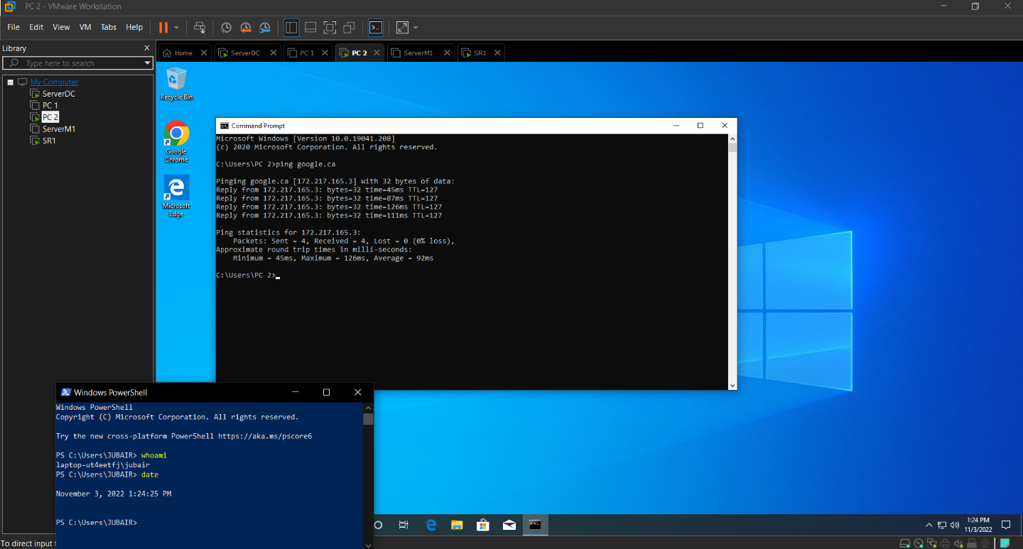

1. From PC2 ping 192.168.20.11

# (Take Screenshot)



## Step 9: Configure ServerM1 as a VPN router

1. Add the remote access role
2. Select “DirectAccess and VPN (RAS)” and Routing
3. Configure Routing and Remote Access
4. Select Routing and Remote Access
5. Configure Routing and Remote Access
6. Select Network address translation NAT VPN
7. Select the Ethernet interface on 192.168.20.11
8. IP Address Assignment from a specifies range of addresses
9. Range 192.168.10.100 to 192.168.10.119
10. Use Routing and Remote access

## Step 10: VPN from either PC2 or PC2

1. On ServerDC-initials, enable the Windows VPN authentication for Administrator user.

From PC2 connect to the VPN

1. Take a screenshot that it worked. (Connected and now has 2 IP addresses)

**(Take Screenshot)**

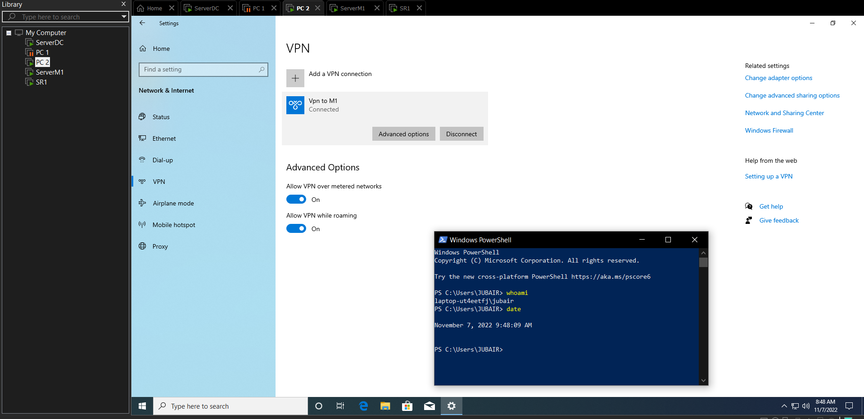

1. Take a screenshot that ping 192.168.10.20 is successful.

# (Take Screenshot)

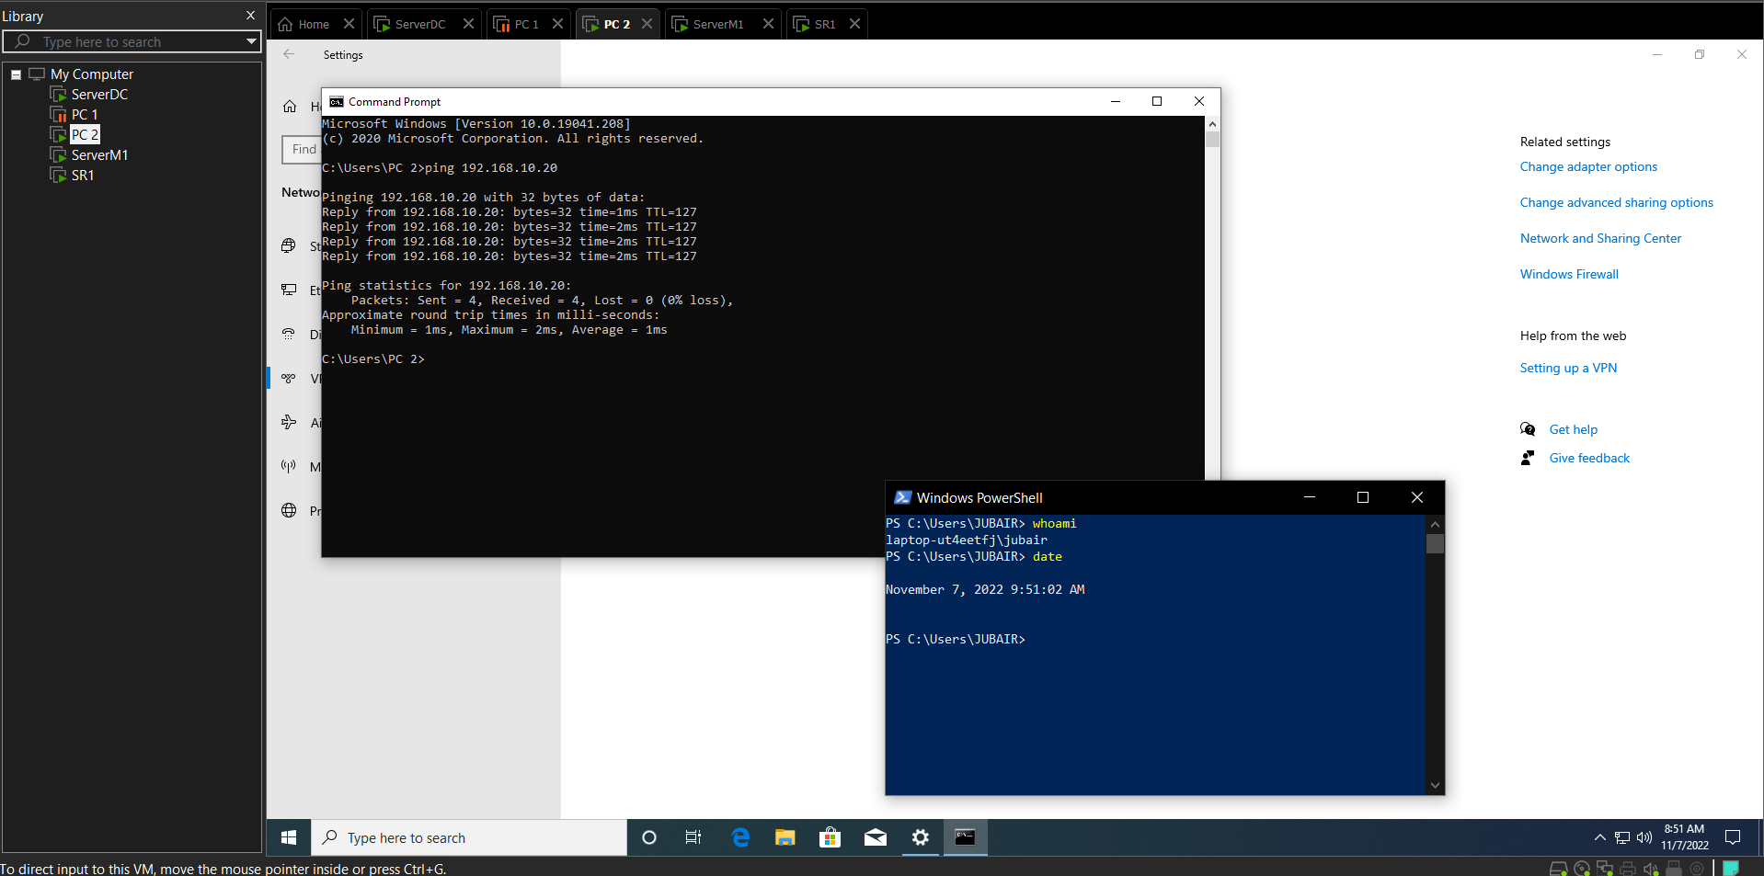

**Step 11. Configure ServerM1 as a DHCP server.**

1. Scope name 192.168.10.0 Scope
2. Address Pool range 192.168.10.50 to 192.168.10.99
3. Router 192.168.10.21
4. DNS Server 192.168.10.20
5. Lease Duration 2 Hours

**Step 12. Logon to PC1**

1. Make sure the Ethernet Interface is set to obtain an IP automatically
2. From either DOS or PowerShell confirm it has the IP address 192.168.10.50.

# (Take Screenshot)

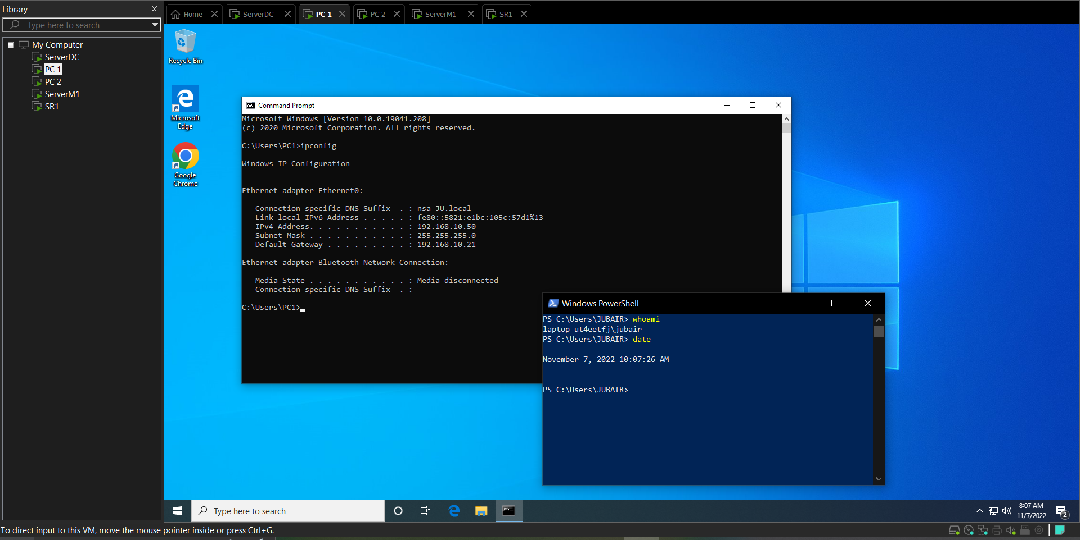

1. Take a screenshot of the result of the ipconfig /all and the ping google.ca commands. **(Take Screenshot)**
2. 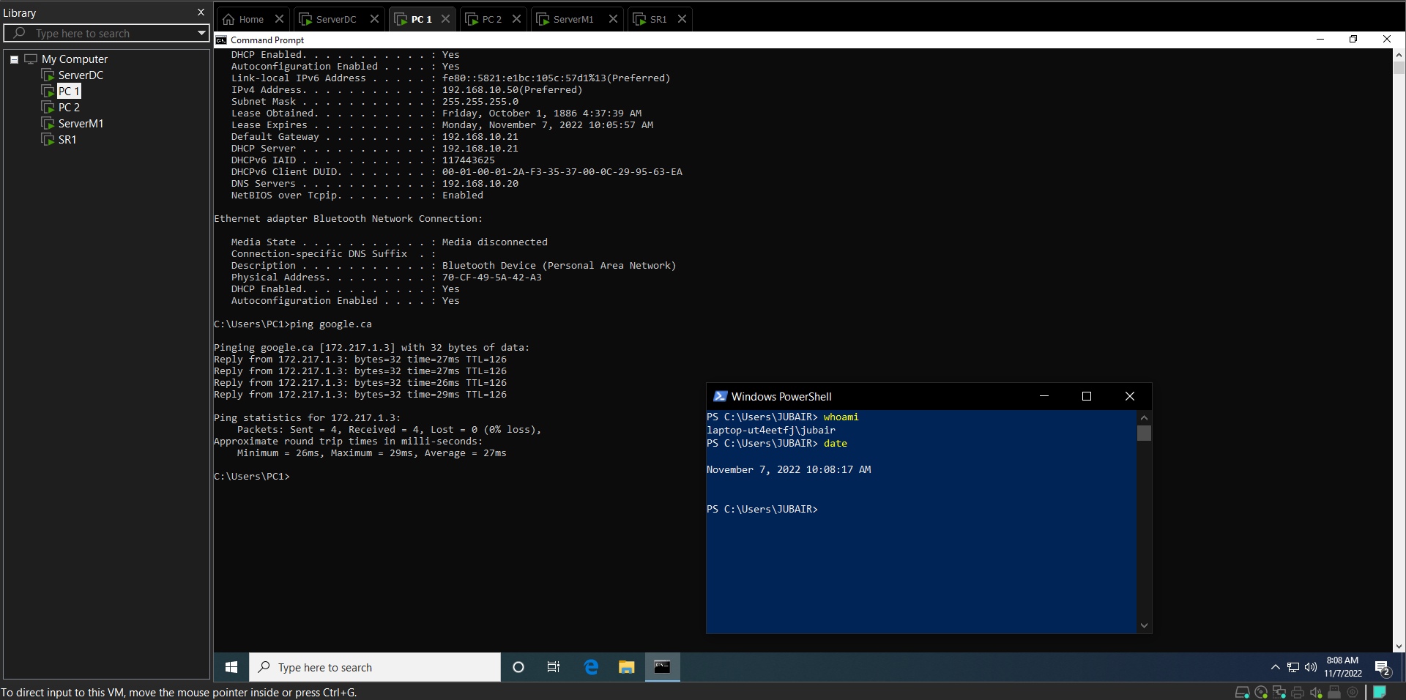

*(End of Part 1)*